CENTRE CARPET.com
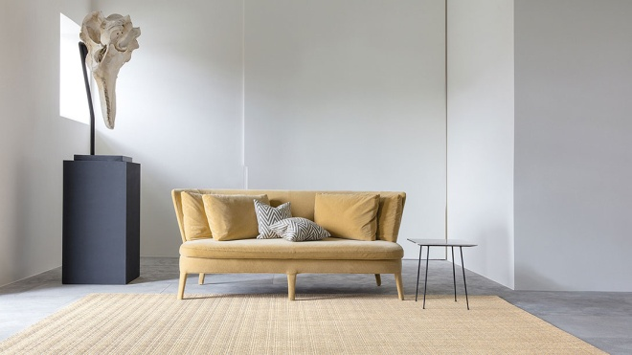
Welcome to the [[[] CENTRE CARPETS , a leading manufacturer and exporter of Carpets, Mats, Rugs , Coir, Sisal and Allied products, With an history of 27 years we are among the leading in the world of decors.
[[[] CENTRE CARPETS enjoys a unique position in the international market for high quality Floor Coverings, Sisal Carpets, Poly carpet, Woolen carpet, Wall to wall carpet & Coir Tails, Rubberized coco fiber sheet, Sea grass matting & rugs, Jute matting’s & Rugs, Brush mats, Rubber door mats, Polypropylene mats, Rope mats, Rubberized mould mats, Bath room cotton mats, Vinyl blocked coir rolls, Coir Rope, Coir fiber, Coir yarn, Manila Rope, Bamboo blinds, Wood blinds, Natural fiber items, Hammocks, Wood crafts, Jute bags, Room slippers, Coconut Shell Products.
For more decors and crafts visit www.windowfashionsindia.com
----------------------------------------------------------------------
SISAL CARPET / Mat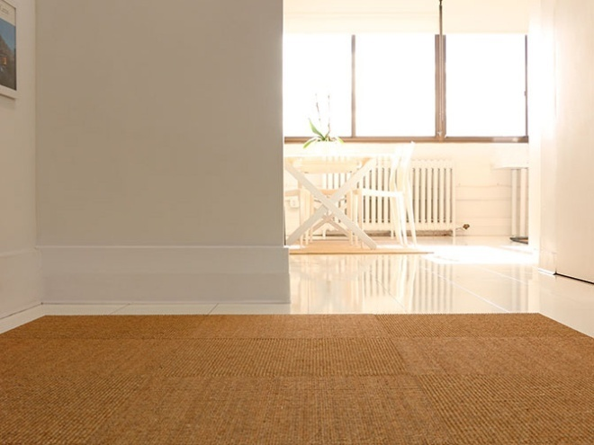
Sisal is a super tough, environmentally friendly fibre that is fashionable, hardwearing and practical. Sisal carpets and rugs are stylish, chic and durable.
We can make Sisal Carpet & Mats in any size and measurement. See our website for more details. http://www.centrecarpet.com/sisalcarpet
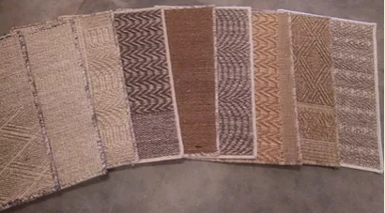
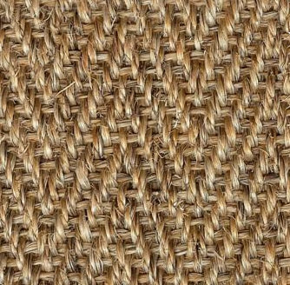

Sisal mats we can offer with side stitched and with rubberized latex behind the mats.

Sisal mats also make perfect wall rugs, for both residential and commercial settings, many use them as wall rugs because they are sound absorbing. They are also fire resistant, making them a safe alternative to your home.

COIR CARPET / MAT

Coir Carpet / Door mats are eco-friendly as they are made out of coir fiber which is extracted from the outer husks of a coconut. This thick and strong coir fiber gives the coir mats its most desirable features of durability, functionality and longevity. 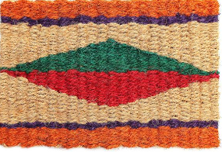

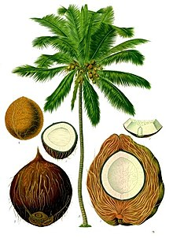

Coir matting's are used for indoors, outdoors, stairs, runner, foyers or as room rugs;

It can be used to cover large areas and our coir matting are great for the home & office with easy maintenance.
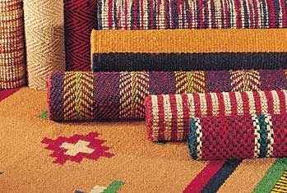

For more details visit

www.centrecarpet.com/coirmat

WOOLEN CARPET

Wool carpets offer softness, durability and a stunning natural appearance, making them a family favorite that won’t compromise on style.

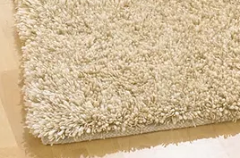

Visit : http://www.centrecarpet.com/woolencarpet

SHAGGY CARPET

Our shaggy rug selection offers a huge range of beautifully soft, thick, deep-pile carpets offering luxurious comfort.

http://www.centrecarpet.com/shaggy

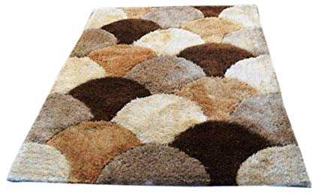

Jute CARPET

Jute is one of the finest and softest of natural floor covering material and this makes it ideal for areas of your house, halls or office floors.

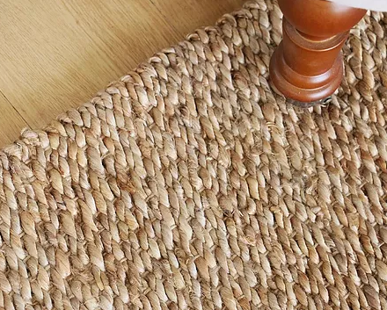

http://www.centrecarpet.com/jutecarpet

Persian CARPET

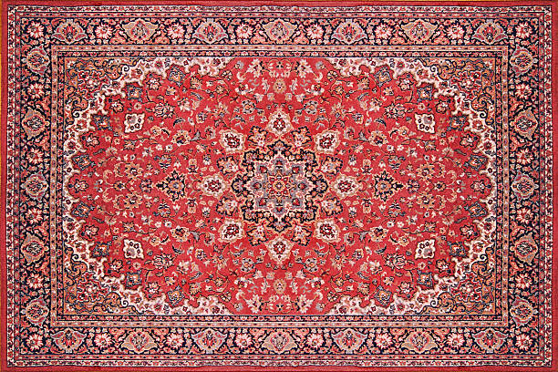

Persian carpet also known as Iranian carpet, is a heavy textile, made for a wide variety of utilitarian and symbolic purposes, produced in Iran (historically known as Persia), for home use, local sale, and export.

Yoga MAT

We offer wide range of Yoga mats such as Rubber, cotton, Natural Pandanus leaf mat, Jute, Grass mats.

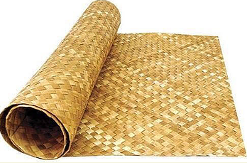

Log on to http://www.centrecarpet.com/yogamat for more details.

Rubber Mat

Models:

* Rubber Pin Mats

* RUBBER Hollow Mats

* Rubber Iron Mats

* Poly Mats

* PVC MATS

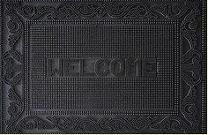

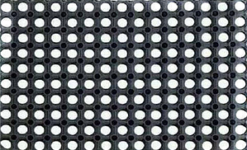

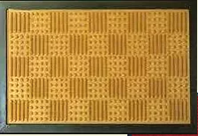

Coir Net / Rope / Coco PEAT

We have various coir products like Coir rope, coco peat, coir net.

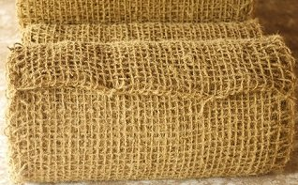

Raw coconut fiber is twisted into single or double yarns (two twisted fibers), then woven by loom into coir nets. Soil erosion is a naturally occurring process that affects all landforms.

Coir Rope is used for insulation and packaging, gardening, fencing, mountaineering, knotting boats, lifters etc...

Coco peat / Coco Fiber Pith is a natural fibre made out of coconut husks. It can be mixed with fertilizers and nutrients according to the specific requirements of the plants.

http://www.centrecarpet.com/coirnet

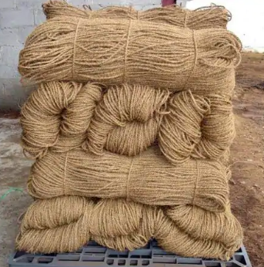

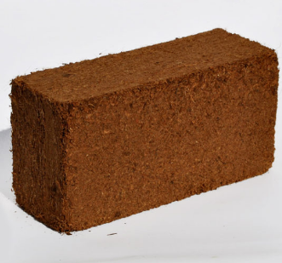

Latex coco sheet

Made with high quality rubber latex and coir fiber.

Its both soft and durable that makes it perfect for beds, mattress, cushions, seats etc

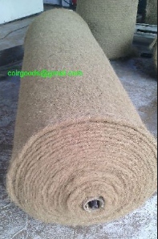

Please visit our parent site, www.windowfashionsindia.com, to shop for indoor and outdoor home furnishings and accessories.

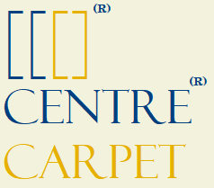

Centre Carpet

Pathirapally 688521

Alleppey, Kerala

India

http://www.centrecarpet.com/

Phone - +91 701217614

/Whatsapp

Email- topcmats@gmail.com

coirgoods@gmail.com

To make an order email us your design, quantity, measurements and designs to topcmaats@gmail.com or Whatsapp us +91 7012176164

We can make Carpets/ Mats in your designs and colors and that takes time for making.

If you want urgent shipping we have lots of attractive stock mats and carpets available.

Also you can personalize your favorite mats with your logo, designs or company name, just send us your logo and we would do the rest.

In case of any queries, or orders don’t hesitate to contact us.
- Regards

Centre Carpet.com

© 2019

BROCHEURE 2019

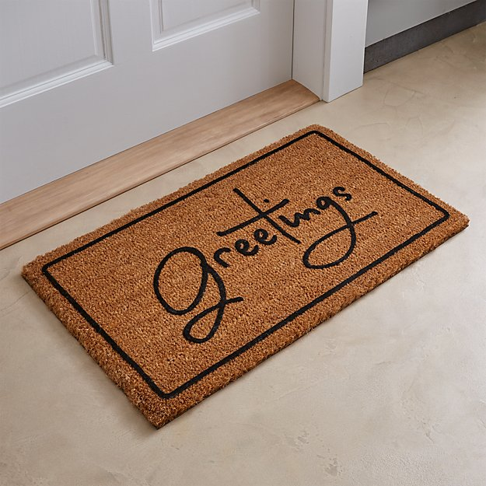

The complete Flooring - Excellency blended with weave

